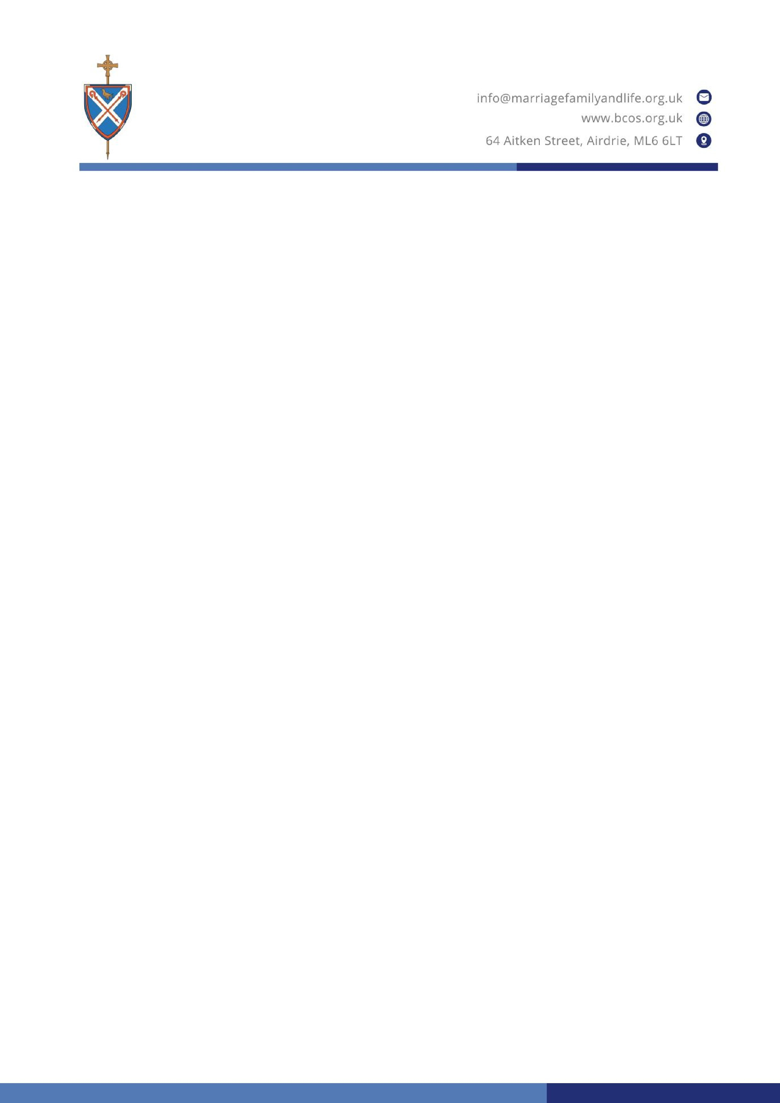

Day for Life 2026

Bishops’ Message

Dear Brothers and Sisters,

Day for Life
presents an opportunity to celebrate the dignity of all human life from
conception to natural end. The theme for 2026 is ‘The Wonder of the Child in the
Womb’.

Every year
Day for Life
falls on Father’s Day and we wish fathers a blessed day. Today
we remember with gratitude the loving care and direction our parents gave to us,
whether they are still with us or have gone to the Lord.

Parenthood is a vocation of joys and hopes, of griefs and anxieties. On this year’s
Day
for Life
, we acknowledge the particular grief of mothers and fathers who have lost a
child before birth or in infancy. Mother’s Day and Father’s Day can be especially
difficult for parents who experience the loss of an infant. Such loss often takes its bodily
toll

upon the mother, and it can leave fathers feeling helpless and unsure of how to
support their family, or of how to express their own grief.

The Church wants to be especially close to parents who have suffered the loss of an
infant. We try to offer spiritual support through the pastoral care and blessing of our
priests, and through the comfort of our liturgy. You only have to reach out to your
priest
or deacon if you would like to know more about this.

Just as importantly, many parents find consolation in their faith and its assurance that
every child, including those who lose their life before they are born or soon after, is
created, willed and deeply loved by God from all eternity. We have the Lord’s p
romise
from the Scriptures that: “
Before I formed you in the womb I knew you, and before you
were born, I consecrated you
” (Jer 1:5).

The Word of God reveals the sacred humanity of the unborn child and perhaps helps us
understand why we feel such profound grief at the loss of a baby. Parents instinctively
grasp how precious and unique the child is whom they have lost and whom they may
al
ready have called by name. They know how no other child can ever replace them.

Science is clear that life begins at fertilisation when a new and unique living human
being comes into existence. Every technological development in recent decades has

given us insight into how life in the womb unfolds for each of us. At conception, our
gender, genetic makeup and eye and hair colour are already determined. As early as five
weeks, our heart begins to beat. By ten weeks, we can move and respond to touch an
d,
beginning two weeks later, we have the capacity to feel pain. By eighteen weeks, our
mother can sense our movement in the womb. By twenty
-
seven weeks, we can
recognise the voices of our parents. For some decades, parents have been able to observe
some o
f these stages through ultrasound scans during pregnancy. The more we learn
about the science, the more we understand the teaching of the Church on the unique
value of the unborn baby.

This understanding, however, is not complete without the recognition that, from the
beginning, every human being is not just a body but also an immortal soul, with a unique
and eternal connection with God, our Creator.

It is because of what both science and faith reveal to us that the Church and many people
of good will have always held that the unborn child merits the full protection of the law,
and why we have always rejected elective abortion.

This
Day for Life
2026
, we reflect on the wonder of human life from the moment of
fertilisation. We remember how the Lord Jesus Christ Himself sanctified and
experienced the beginning of life in the world as an unborn child, hidden in the womb
of Mary. Mary knew that she wa
s carrying the Son of God
–

God and man
–

as soon as
He was conceived. John the Baptist leapt in his mother Elizabeth’s womb when Mary
greeted her. Our Lady treasured Our Lord in her heart and womb until His birth.

We, in our turn, commit ourselves to work and pray for our society to cherish the value
of every little one, especially those at the earliest stage of human life, and to help our
parish communities support all those in our midst who have suffered the loss
of a child.

Most Reverend John Sherrington
,

Archbishop of Liverpool
,
England and Wales

Most Reverend Kevin Doran

Bishop of Elphin and of Achonry
,
Ireland

Right Reverend John Keenan

Bishop of Paisley
,
Scotland

